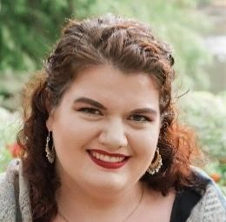
SARAH KATHRYN CURTIS, MEZZO-SOPRANO
sarah.kathryn.curtis.singer@gmail.com
(657) 291-6469

ROLES PERFORMED  Mezzo-Soprano* Snow Angel  Ursule Béatrice et Bénédict  Giulio Cesare Giulio Cesare in Egitto  Mistress Quickly Falstaff  Hippolyta A Midsummer Night’s Dream  Augusta Tabor The Ballad of Baby Doe  Berta Il barbiere di Siviglia  Jo March Little Women  Witch Hansel and Gretel  Sorceress Dido and Aeneas  Marcellina Le nozze di Figaro  Zita Gianni Schicchi (English)  Nettie Fowler Carousel  SCENES AND COVERS  Carmen Carmen  Dritte Dame Die Zauberflöte  Ulrica Un ballo in maschera  Florence Pike (Cover) Albert Herring  La Zia Principessa Suor Angelica  Sally Hand of Bridge  Lucretia The Rape of Lucretia  Tisbe La Cenerentola  CONCERT AND ORATORIO  Female Singer Lady of the Camellias  Alto Soloist The Messiah  EDUCATION AND TRAINING | University of Kansas Opera  Landlocked Opera  University of Kansas Opera  Lawrence Opera Theater  University of Kansas Opera  Opera in the Ozarks  Opera in the Ozarks  Simpson College Opera  Simpson College Opera  Simpson College Opera  Blooming Voce Opera Workshop  Simpson College Opera  Simpson College Opera  Landlocked Opera  Landlocked Opera  Opera in the Ozarks  Chicago Summer Opera  Chicago Summer Opera  Chicago Summer Opera  Chicago Summer Opera  Simpson College Opera  Kansas City Ballet  Central Iowa Symphony | 2021  2019  2019  2019  2019  2018  2018  2018  2017  2016  2016  2015  2014  2019  2019  2018  2016  2016  2016  2016  2016  2019  2015
The University of Kansas Master of Music, Opera Performance  Opera in the Ozarks |  | 2020  2018
Simpson College Bachelor of Music, Vocal Performance with French Minor 2017
Blooming Voce Opera Workshop |  |  | 2016  2016
Chicago Summer Opera

